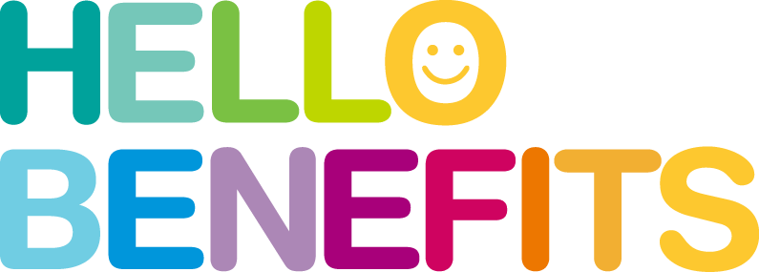

BAB BENEFITS FOR YOUR BUSINESS
- Federal tax incentives for employers (work opportunity tax credit for qualifying employers)
- HR assistance (developing job descriptions, identifying career ladders, providing info on labor laws, equal opportunity, and sexual harassment)
- Speaker services (specialized training for your business and skills upgrade for employees)
- Resource Center (office space to conduct interviews, recruitments, research, etc.) – available later
- Research in areas such as the economy, business trends, and Labor Market Information (LMI)
- Recruitment services
- Business Formation/Start up consultation (business plans, checklists, legal information, etc.)
- Access to business building and management software
- Industry focus group (design a focus group to study a business issue or industry opportunities)
- Networking opportunities with other like-minded business owners and entrepreneurs (possible supplier, partnership and vendor services)
- Workshops, webinars and training presentations
- Marketing services and assistance
- Financing/Access to Capital
- Business Needs Assessment
- Permits/Licenses/Certifications Info
- Legal/Tax Consulting
- Your business card, biography with professional headshot, and website address displayed on a special pin on our Pinterest board
- An invitation to our Mastermind group called BAB Masterminds
- Opportunity for more clientele
- Exclusive business resources
- Free event tickets to our events
- A chance to give back by donating a portion of your revenue to a worthy cause
- Meet new potential business partners
- Meet new potential vendors that you may need to keep your business thriving
- Find out how to get more access to business capital (some you won't have to pay back)
- Share your expertise and build your social media following and engagements

*More benefits will be added according to needs and suggestions

Rainbow Universe Pageants, LLC – BAB Membership. All Rights Reserved © 2019 www.rainbowuniversepageants.com/bab

